Warholova aukčná olympiáda

„Biznis art je krok, ktorý nasleduje po umení“
Andy Warhol

Od 8. do 11. novembra 2010 sa konali najdôležitejšie aukcie svetového umenia v troch najsilnejších aukčných spoločnostiach – Christie´s, Sotheby´s a Philips de Pury. Všetky aukcie sa realizovali v meste New York a pre obchod s umením znamenali ikonický prevrat. Hviezdny licitátor z aukčného domu Sotheby´s Tobias Meyer zdôraznil, že tieto aukcie mali obrovský úspech a znamenajú novú podobu umeleckého obchodu. Epicentrom tejto zmeny bol práve Rusín Andy Warhol, kultová postava umenia 20. storočia, ktorý nielenže naplnil očakávania týchto aukčných spoločností, ale ďaleko ich aj prekročil. Andy Warhol jednoducho rehabilitoval, posunul a vytvoril ďalší nový priestor na umeleckom trhu, ktorý hlavne vďaka nemu zažíva prvú etapu svojej renesancie po období svetovej hospodárskej krízy. Uvediem iba niekoľko faktografických údajov :
– Počas týchto 4 dní sa v spomínaných aukčných spoločnostiach vydražilo 516 umeleckých diel umelcov tvoriacich v období prevažne druhej polovice 20. storočia v celkovej sume 674.000.000,- USD .
– Z týchto 516 umeleckých diel sa dražilo 45 od Andyho Warhola – vydražili sa všetky a to v celkovej hodnote 195.446.000,- USD, čo je takmer jedna tretina z celkovej sumy všetkých vydražených diel.
– Najdrahšie predané dielo od Andyho Warhola bolo pod názvom „ Men in Her Life“ a vydražilo sa za sumu – 63,3 milióna USD.
– K ďalším TOP predaným Warholovým dielam počas týchto štyroch aukčných dní patrili :
1. „Coca-Cola“ – vydražená za 35,4 milióna USD,
2. „Big Campbell's Soup Can with Can Opener (Vegetable)“ – 23,8 mil. USD,
3. „Campbell's Soup Can (Tomato)“ – 9 mil. USD,
4. „The Last Supper“ – 6,8 mil. USD.
Zároveň zdôrazňujem, že viac ako polovica zo spomínaných 45 vydražených diel Andyho Warhola sa predala za minimálne 100-percentu vyššiu cenu, akou bola cena vyvolávacia. V prípade diela „ Brillo Box“ sa dokonca vyvolávacia cena 600.000,- USD vyšplhala v priebehu pár minút na konečnú neuveriteľnú sumu 3 milióny USD a grafika na papieri z roku 1962 pod názvom „Dance Diagram“ sa vydražila za 1,5 milióna USD z vyvolávacej ceny 400.000,- USD.
Aj napriek tomu, že svetová hospodárska kríza sa obchodu s umením dotkla iba okrajovo, takto rekordná rehabilitácia trhu s umením spôsobila doslova senzáciu a demonštrovala tým silnú platformu investície do umenia. Najdôležitejším momentom týchto štyroch silných aukčných dní je, že popri impresionistickom umení sa definitívne atestoval pop-art ako „ikonická“ línia umenia 20. storočia najmä v oblasti umeleckého obchodu, ale aj v oblasti teórie umenia a výtvarnej kritiky, čím častejšie sa prejavujúcej najmä v kvantite, ale aj v kvalite prezentácie pop-artových diel v najlepších múzeách a galériách sveta. A jeho hnacím motorom je ANDY WARHOL, ktorý posunul seba, ale aj ďalších pop-artistov ( Roy Lichtenstein, Keith Haring, Tom Wasselmann ... ) do tej istej „ligy“, v akej sú už teraz napríklad H. Matisse či P. Picasso. Verifikáciou tejto mojej úvahy je jasná demonštrácia nižšie uvedených diel a ich predajných, vydražených cien! A v tejto rovine úvah si dovolím ostať aspoň do najbližších jarných aukcií v roku 2011 a počkať si, na ktorej TOP priečke sa opäť umiestni Andy Warhol ako najlepšie zarábajúci umelec po smrti. Ak máte pocit, že táto krátka štúdia udalostí z posledných siedmych dní na umeleckom trhu je príliš o biznise, tak opakujem výrok zo začiatku: „Biznis art je krok, ktorý nasleduje po umení“ – Andy Warhol.
Martin CUBJAK, kurátor a galérista

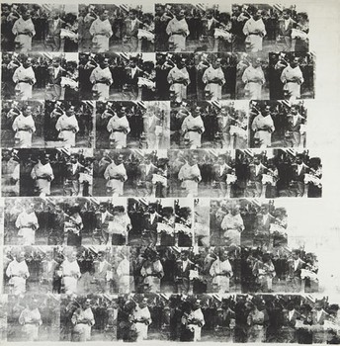

ANDY WARHOL
1928 - 1987
Men in Her Life

Executed in October-November 1962.

Silkscreen and pencil on primed canvas.

84 1/2 x 83 1/4 in. (214.6 x 211.5 cm).

Estimate : $40 and $50 million

Lot Sold. Hammer Price with Buyer's Premium: 63,300,000 USD

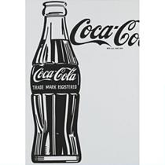

ANDY WARHOL
1928 - 1987
COCA-COLA [4] [LARGE COCA-COLA]
signed and dated 62 on the reverse
acrylic, pencil and Letraset on canvas
20,000,000—25,000,000 USD
Lot Sold. Hammer Price with Buyer's Premium: 35,362,500 USD

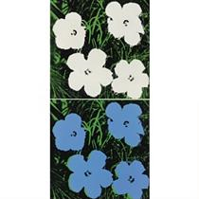

ANDY WARHOL
1928 - 1987
FLOWERS
each: signed and dated 64 on the overlap
acrylic and silkscreen ink on canvas in two parts
each: 24 x 24 in. 61 x 61 cm.
2,500,000—3,500,000 USD
Lot Sold. Hammer Price with Buyer's Premium: 2,658,500 USD

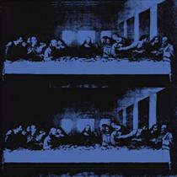

ANDY WARHOL
1928 - 1987
THE LAST SUPPER
stamp signed and inscribed with authentication by Frederick Hughes in 1986 on the overlap
synthetic polymer paint silkscreened on canvas
40 x 40 in. 101.6 x 101.6 cm.

4,000,000—6,000,000 USD
Lot Sold. Hammer Price with Buyer's Premium: 6,802,500 USD

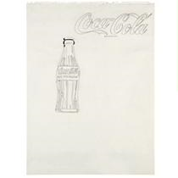

ANDY WARHOL
1928 - 1987
COCA-COLA
signed twice and dated 1962 and 62 on the reverse
pencil and ink on paper
24 x 18 in. 60.8 x 45.5 cm.
1,000,000—1,500,000 USD
Lot Sold. Hammer Price with Buyer's Premium: 1,482,500 USD

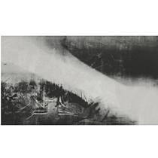
ANDY WARHOL
1928 - 1987
SHADOWS
synthetic polymer, acrylic and silkscreen ink on canvas
78 x 138 in. 198.1 x 350.5 cm.
1978
3,000,000—4,000,000 USD
Lot Sold. Hammer Price with Buyer's Premium: 4,226,500 USD
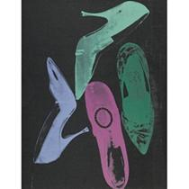
ANDY WARHOL
1928 - 1987
DIAMOND DUST SHOES
signed and dated 1980 on the reverse
acrylic, silkscreen ink and diamond dust on canvas
1,200,000—1,800,000 USD
Lot Sold. Hammer Price with Buyer's Premium: 1,426,500 USD

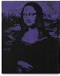
ANDY WARHOL
1928 – 1987
Mona Lisa, 1979
Acrylic and silkscreen ink on canvas. 25 1/8 x 20 1/8 in. (63.8 x 51.1 cm)
Signed and dated "Andy Warhol 1979" on the overlap; also stamped with the Andy Warhol Authentication Board Inc. seals and numbered "A109·011" on the overlap.
Estimate $1,500,000 - $2,500,000
Lot Sold. Hammer Price with Buyer's Premium: 1,986,500 USD
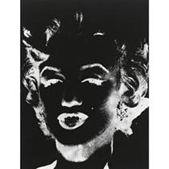

ANDY WARHOL
1928 - 1987
MARILYN MONROE (FROM THE REVERSAL SERIES)
screenprint on HMP paper
31 1/4 by 23 3/8 in. 79.4 by 59.4 cm.
Executed in 1978, this work is unique and is stamped by The Estate of Andy Warhol, The Andy Warhol Foundation for the Visual Arts, Inc. and numbered VF UP48.58 on the reverse.
100,000—150,000 USD
Lot Sold. Hammer Price with Buyer's Premium: 200,500 USD

51.959.000,- USD + 63.300.000,-USD = 117.445.500,- USD
Sothebys + Philips de Pury, New York – Rockefeller Plaza

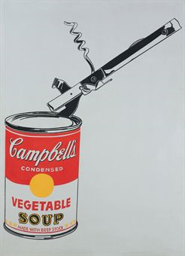

Andy Warhol (1928-1987)
Big Campbell's Soup Can with Can Opener (Vegetable)
signed and dated 'Andy Warhol 62' (on the stretcher); signed again 'Andy Warhol 62' (on the reverse)
casein and graphite on linen
72 x 52 in. (182.9 x 132.1 cm.)
Painted in 1962.

Price Realized $23,882,500

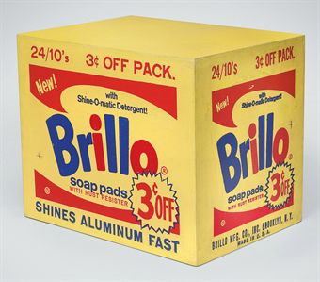

Andy Warhol (1928-1987)
Brillo Box (3 cents off)
signed 'Andy Warhol' (on the underside); stamped by the Andy Warhol Art Authentication Board, Inc. and numbered 'A102.965' (on the underside)
silkscreen ink and house paint on plywood
13 1/8 x 16 x 11½ in. (33.3 x 40.6 x 29.2 cm.)
Executed in 1963-1964.

Estimate $600,000 - $800,000

Price Realized - $3,050,500

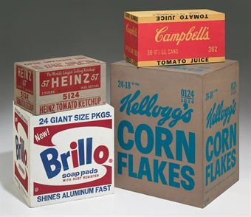

Andy Warhol (1928-1987)
A Set of Boxes
Heinz Ketchup
stamped by the Andy Warhol Authentication Board and numbered 'A391.102' (on the underside)
silkscreen ink and house paint on plywood
8½ x 15½ x 10½ in. (21.6 x 39.4 x 26.7 cm.)
Executed in 1964.

Estimate - $1,200,000 - $1,800,000

Price Realized - $2,322,500

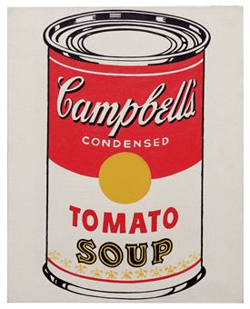

Andy Warhol (1928-1987)
Campbell's Soup Can (Tomato)
signed and dated 'ANDY WARHOL 62' (on the reverse)
graphite and casein on canvas
20 x 16 in. (50.8 x 40.6 cm.)
Painted in 1962.

Estimate - $6,000,000 - $8,000,000

Price Realized - $9,042,500

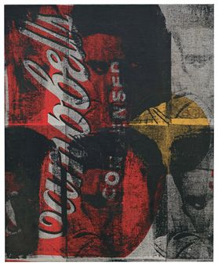

Andy Warhol (1928-1987)
Campbell's Elvis
signed and incorrectly dated 'ANDY WARHOL 64' (on the reverse)
silkscreen ink and acrylic on canvas
20 x 16¼ in. (50.8 x 41.2 cm.)
Painted in 1962.

Estimate $600,000 - $800,000

Price Realized - $1,482,500

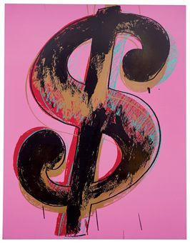

Andy Warhol (1928-1987)
Dollar Sign
stamped twice with the Estate of Andy Warhol stamp; stamped four times with the Andy Warhol Foundation for the Visual Arts, Inc. stamps and numbered 'PA30.076' (on the overlap and on the reverse)
synthetic polymer and silkscreen ink on canvas
90 x 70 in. (229 x 178 cm.)
Painted in 1981.

Estimate - $2,500,000 - $3,500,000

Price Realized - $5,122,500

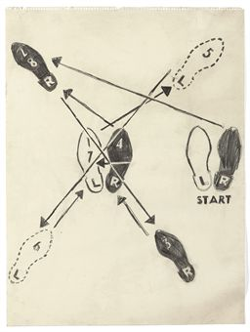

Andy Warhol (1928-1987)
Dance Diagram
signed, inscribed and dated 'Andy Warhol 62 CASTELLI' (lower right)
graphite on paper
24 x 18 in. (60.9 x 45.7 cm.)
Drawn in 1962.

Estimate - $400,000 - $600,000

Price Realized - $1,538,500
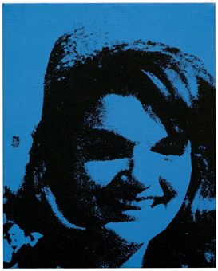

Andy Warhol (1928-1987)
Jackie
stamped with the Estate of Andy Warhol and stamped twice with the Andy Warhol Foundation for the Visual Arts stamps and numbered 'PA.56.103' (on the reverse and on the stretcher)
acrylic and silkscreen ink on canvas
20 x 16 in. (50.8 x 40.6 cm.)
Painted in 1964.

Estimate - $600,000 - $800,000

Price Realized - $1,650,500

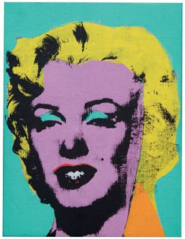

Andy Warhol (1928-1987)
Marilyn
acrylic and silkscreen ink on linen
14 x 10¾ in. (35.5 x 27.3 cm.)
Painted in 1962.

Estimate - $4,000,000 - $6,000,000

Price Realized - $4,450,500
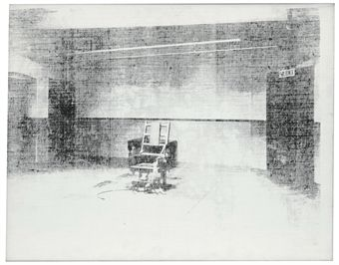

Andy Warhol (1928-1987)
Little Electric Chair
stamped with the Estate of Andy Warhol and the Andy Warhol Foundation for the Visual Arts, Inc., stamps and numbered 'PA57.001' (on the overlap)
silkscreen ink on linen
22 x 28 in. (55.9 x 71.1 cm.)
Painted in 1964-1965.

Estimate - $2,000,000 - $3,000,000

Price Realized - $2,602,500

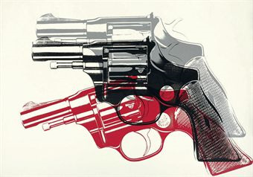

Andy Warhol (1928-1987)
Guns
signed and dated 'Andy Warhol 1982' (on the overlap); stamped with the Andy Warhol Art Authentication Board, Inc. stamp and numbered 'A117.962' (on the overlap)
synthetic polymer and silkscreen inks on canvas
56¼ x 80 1/8 in. (142.9 x 203.5 cm.)
Painted in 1982.

Estimate - $1,800,000 - $2,200,000

Price Realized - $4,450,500

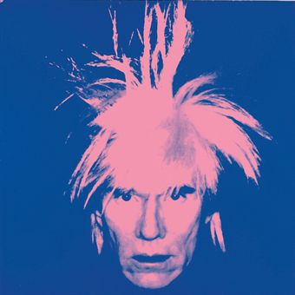

Andy Warhol (1928-1987)
Self-Portrait
stamped twice with The Estate of Andy Warhol and Andy Warhol Foundation for the Visual Arts, Inc. stamps and numbered 'P040.028' (on the overlap and on the stretcher)
synthetic polymer and silkscreen inks on canvas
40¼ x 40¼ in. (102.2 x 102.2 cm.)
Painted in 1986.

Estimate - $3,500,000 - $4,500,000

Price Realized - $4,450,500

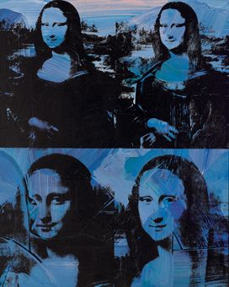

Andy Warhol (1928-1987)
Mona Lisa
signed 'Andy Warhol' (on the overlap)
synthetic polymer and silkscreen ink on canvas
50 1/8 x 40 1/8 in. (127.3 x 101.9 cm.)
Painted in 1978.

Estimate - $1,800,000 - $2,200,000

Price Realized - $3,610,500

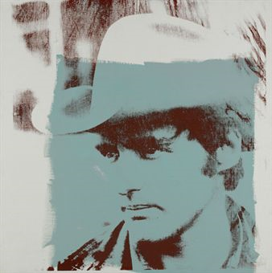

Andy Warhol (1928-1987)
Dennis Hopper
stamped twice with The Estate of Andy Warhol stamps and numbered twice 'P050.415' (on the overlap and on the stretcher)
synthetic polymer and silkscreen inks on canvas
40 x 40 in. (101.6 x 101.6 cm.)
Painted in 1971.

Estimate - $800,000 - $1,200,000

Price Realized - $962,500

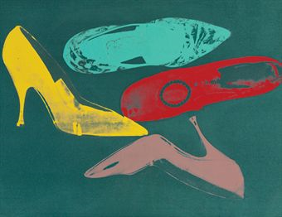

Andy Warhol (1928-1987)
Diamond Dust Shoes
stamped with The Estate of Andy Warhol and the Andy Warhol Foundation for the Visual Arts, Inc. stamps and numbered 'PA70.014' (on the overlap); numbered again 'PA70.014' (on the stretcher)
synthetic polymer and silkscreen inks on canvas with diamond dust
70 x 90 in. (177.8 x 228.6 cm.)
Painted in 1980-1981.

Estimate - $1,000,000 - $1,500,000

Price Realized - $1,762,500
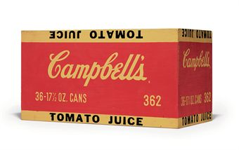

Andy Warhol (1928-1987)
Campbell's Tomato Juice Box
signed and inscribed 'Andy Warhol Billie Burke' (on the underside)
silkscreen ink and house paint on plywood
10 x 19 x 19½ in. (25.4 x 48.3 x 24.1 cm.)
Executed in 1964.

Estimate - $150,000 - $200,000

Price Realized - $422,500

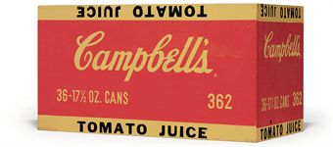

Andy Warhol (1928-1987)
Campbell's Tomato Juice Box
stamped with the Estate of Andy Warhol and the Andy Warhol Foundation for the Visual Arts and numbered 'SC12.035' (on the underside)
silkscreen ink and house paint on plywood
10 x 19 x 9 7/8 in. (25.5 x 48.3 x 25.1 cm.)
Executed in 1964.

Estimate - $150,000 - $200,000

Price Realized - $482,500

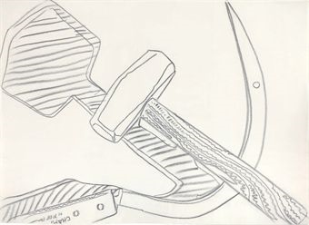

Andy Warhol (1928-1987)
Hammer and Sickle
stamped with the Estate of Andy Warhol and the Andy Warhol Foundation for the Visual Arts, Inc., stamps and numbered '31.00' (on the reverse)
graphite on paper
20½ x 28¼ in. (52 x 71.7 cm.)
Drawn in 1977.

Estimate - $40,000 - $60,000

Price Realized - $52,500

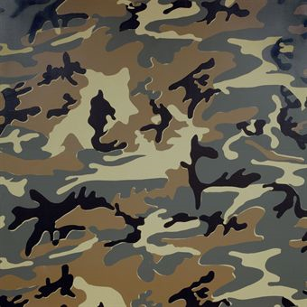

Andy Warhol (1928-1987)
Camouflage
stamped twice with the Estate of Andy Warhol stamps and twice with the Andy Warhol Foundation for the Visual Arts, Inc. stamps and numbered 'PA85.032' (on the overlap)
synthetic polymer and silkscreen ink on canvas
72 x 72 in. (182.8 x 182.8 cm.)
Painted in 1986.

Estimate - $600,000 - $800,000

Price Realized - $1,094,500
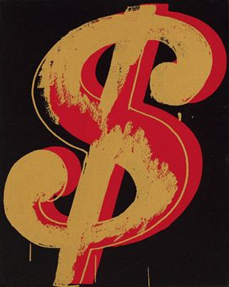

Andy Warhol (1928-1987)
Dollar Sign
stamped with the Estate of Andy Warhol and the Andy Warhol Foundation for the Visual Arts, Inc. stamps and numbered 'PA30.050' (on the overlap)
synthetic polymer and silkscreen ink on canvas
20 x 16 in. (50.8 x 40.6 cm.)
Painted in 1981.

Estimate $250,000 - $350,000

Price Realized - $734,500

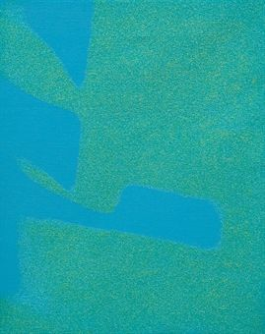

Andy Warhol (1928-1987)
Shadows
synthetic polymer and silkscreen ink on canvas with diamond dust
14 x 11 in. (35.5 x 27.9 cm.)
Executed in 1980.

Estimate - $60,000 - $80,000

Price Realized - $182,500

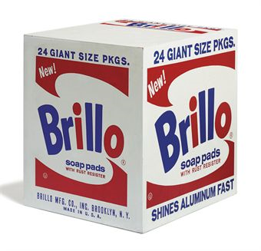

Andy Warhol (1928-1987)
Brillo Soap Pads
silkscreen ink on plywood

20 x 20 x 17 in. (50.8 x 50.8 x 43.2 cm.)
Executed in 1964-1969.

Estimate - $350,000 - $450,000

Price Realized - $758,500

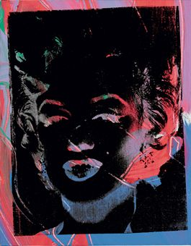

Andy Warhol (1928-1987)
Marilyn (Reversal Series)
stamped with signature 'Andy Warhol' (on the overlap); stamped with the Andy Warhol Art Authentication Board Inc. stamp and numbered 'A118.971' (on the overlap)
synthetic polymer and silkscreen ink on canvas
20 x 16 in. (50.8 x 40.6 cm.)
Painted in 1979-1986.

Estimate - $400,000 - $600,000

Price Realized - $962,500
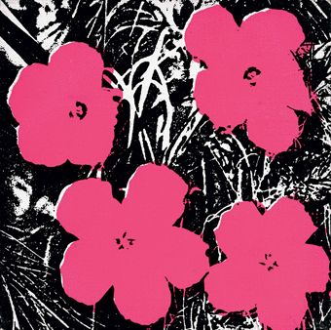

Andy Warhol (1928-1987)
Flowers
signed with initials and dated 'A.W. 64' (on the overlap); stamped with the Andy Warhol Art Authentication Board, Inc. stamp and numbered 'A139.984' (on the overlap)
synthetic polymer and silkscreen ink on canvas
8 x 8 in. (20.3 x 20.3 cm.)
Painted in 1964.

Estimate - $180,000 - $220,000

Price Realized - $446,500

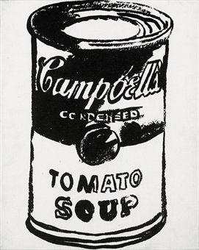

Andy Warhol (1928-1987)
Campbell's Soup Can (Tomato Soup)
signed and dated 'Andy Warhol 85' (on the overlap)
synthetic polymer and silkscreen ink on canvas
20 x 16 in. (50.8 x 40.6 cm.)
Painted in 1985.

Estimate - $350,000 - $450,000

Price Realized - $542,500
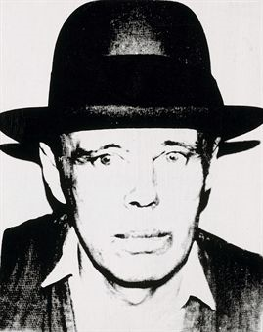

Andy Warhol (1928-1987)
Joseph Beuys
stamped with the Estate of Andy Warhol stamp and twice with the Andy Warhol Foundation for the Visual Arts, Inc. stamps and numbered 'PA62.005' (on the overlap)
synthetic polymer and silkscreen ink on canvas
20 x 16 in. (50.8 x 40.6 cm.)
Painted in 1980.

Estimate - $200,000 - $300,000

Price Realized - $362,500

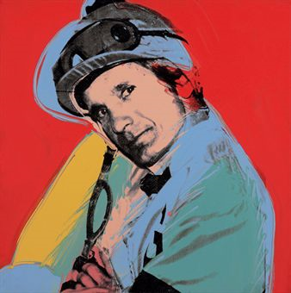

Andy Warhol (1928-1987)
Willie Shoemaker
signed, titled and dated 'Andy Warhol Willie Shoemaker 78' (on the overlap)
synthetic polymer and silkscreen ink on canvas
40 x 40 in. (101.6 x 101.6 cm.)
Painted in 1978.

Estimate - $300,000 - $400,000

Price Realized – $470,500
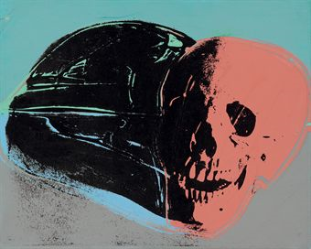

Andy Warhol (1928-1987)
Skull
signed 'Andy Warhol' (on the overlap)
synthetic polymer and silkscreen ink on canvas
15¼ x 19 in. (38.7 X 48.2 CM.)
Painted in 1976-1977.

Estimate - $500,000 - $700,000

Price Realized - $578,500

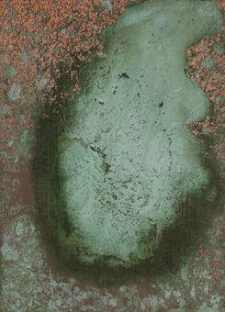

Andy Warhol (1928-1987)
Oxidation Painting
stamped by the Estate of Andy Warhol and the Andy Warhol Foundation for the Visual Arts, Inc., New York stamps and numbered 'PA45.103' (on the reverse)
copper metallic pigment and urine on canvas
13¾ x 10 in. (34.9 x 25.4 cm.)
Executed in 1978.

Estimate - $50,000 - $70,000

Price Realized - $158,500
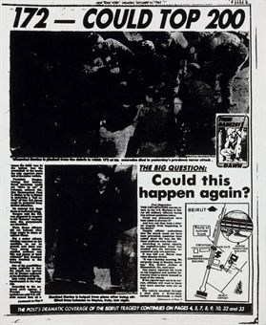

Andy Warhol (1928-1987)
New York Post, Page Three ("172-Could Top 200")
stamped twice with the Estate of Andy Warhol stamps and stamped with the Andy Warhol Foundation for the Visual Arts, Inc. stamp and numbered 'PA94.009' (on the overlap).
synthetic polymer and silkscreen ink on canvas
24 x 20 in. (60.9 x 50.8 cm.)
Painted circa 1983.

Estimate - $120,000 - $180,000

Price Realized - $134,500

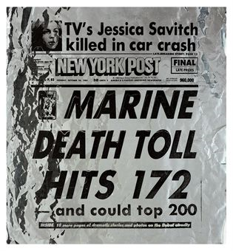

Andy Warhol (1928-1987)
New York Post, Page One
stamped with the Estate of Andy Warhol and the Andy Warhol Foundation for the Visual Arts, Inc., stamps and numbered 'SC26.001' (on the reverse)
sythentic polymer and silkscreen ink on aluminum sheeting
26 x 24 in. (66 x 60.9 cm.
Painted circa 1984.

Estimate - $60,000 - $80,000

Price Realized - $92,500
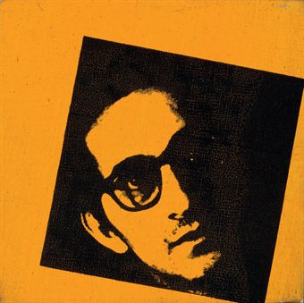

Andy Warhol (1928-1987)
Frank Stella
stamped with the Andy Warhol Art Authentication Board stamp and numbered 'A100.984' (on the overlap)
synthetic polymer and silkscreen ink on canvas
8 x 8 in. (20.3 x 20.3 cm.)
Painted in 1967.

Estimate $120,000 - $180,000

Price Realized - $110,500

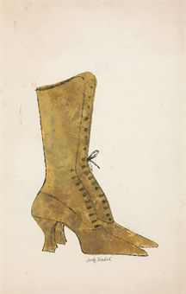

Andy Warhol (1928-1987)
Shoe
signed 'Andy Warhol' (lower center); stamped with the Andy Warhol Authentication Board stamp and numbered 'A119.103' (on the reverse)
gold leaf and ink on paper
22 7/8 x 14½ in. (58.2 x 36.8 cm.)
Executed in 1957.

Estimate - $40,000 - $60,000

Price Realized - $74,500

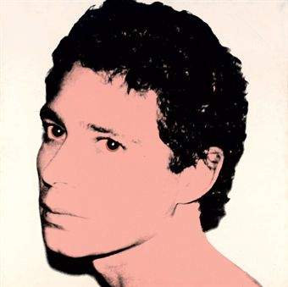

Andy Warhol (1928-1987)
Portrait of Dr. Robert Giller
signed and dated 'Andy Warhol 1981' (on the overlap); stamped with the Andy Warhol Art Authentication Board, Inc. stamp and numbered 'A123.062' (on the overlap)
synthetic polymer and silkscreen ink on canvas
40 x 40 in. (101.6 x 101.6 cm.)
Painted in 1981.

Estimate - $120,000 - $180,000

Price Realized - $158,500

Christies – 10-11.2010 – New York, Rockefeller Plaza

78.201.000,- USD

v celkovej hodnote 195.446.000,- USD

