(WPG)

(AWS)

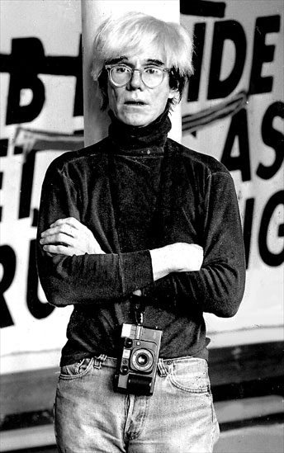

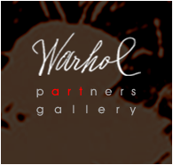

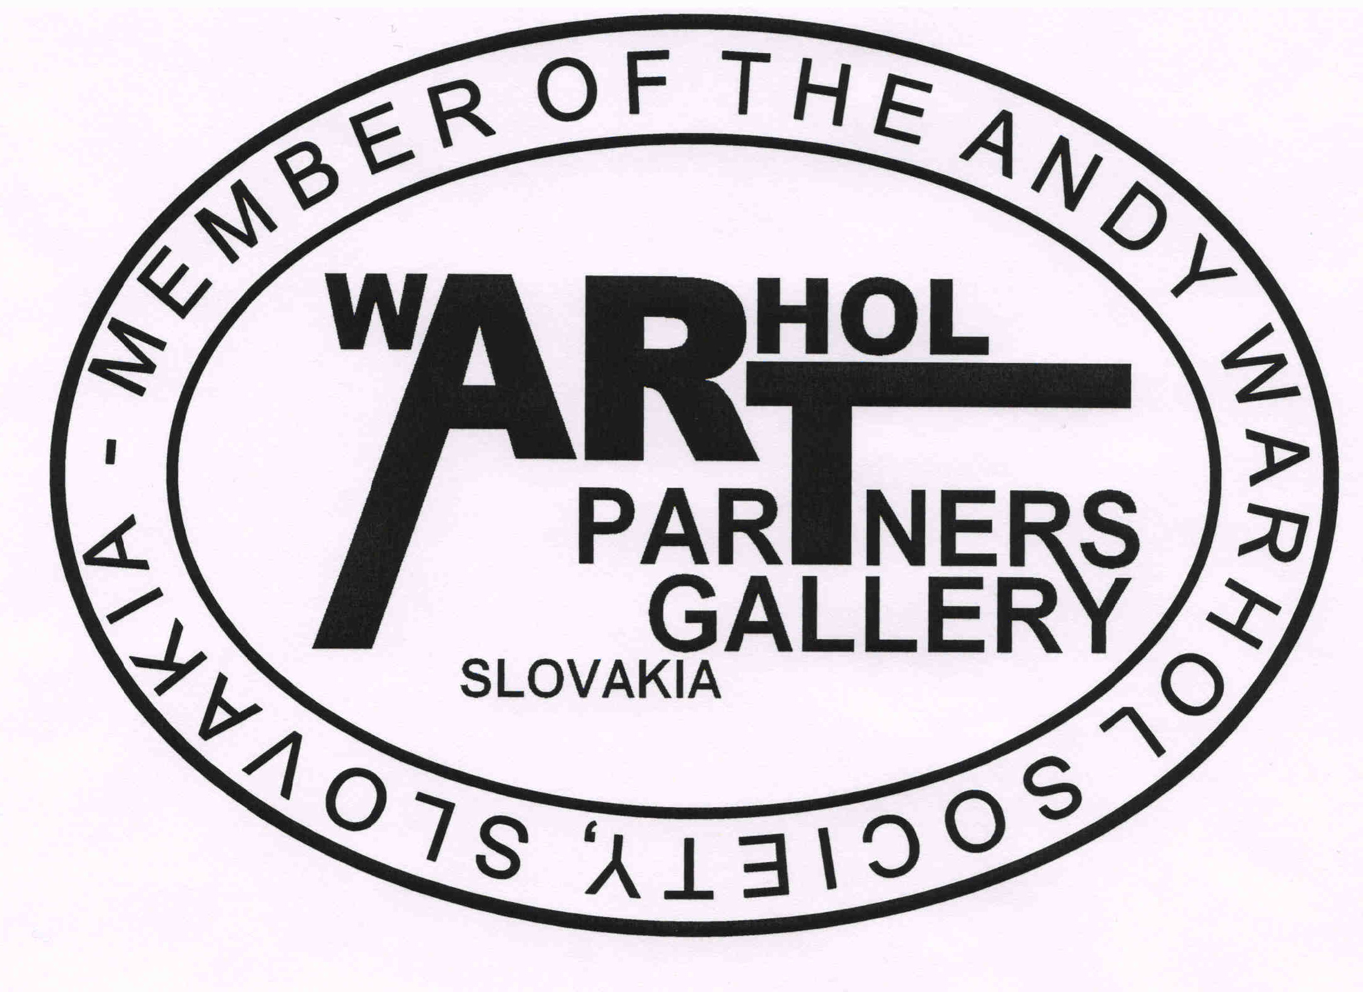

HONORARY PRESIDENT WPG MEMBER Of THE AWS

PRESIDENT AWS AND CHEF ART CURATOR WPG - AWS

BUSINESS DIRECTOR WPG – AWS AND ART CURATOR

VICE PRESiDENT SAW AND ART CURATOR WPG - AWS

Assistant of Honorary President WPG-AWS and President AWS

Administrator
–––––––––––––––––––––––––––––––––––––––––––––––––––––––––––––––––––––––––––––www.warhols.eu
art@warhols.eu

Dr. Timo Vlk: timo@warhols.eu, +421 905 456 892
Dr. Michal Bycko, Ph.D.: michal@warhols.eu, + 421 905 704 460
Martin Cubjak, M.A.: martin@warhols.eu, 421 918 993 572572

Making money is art and working is art and good business is the best art".
Andy Warhol

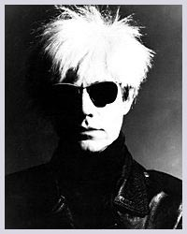 | Welcome to the Warhol partners gallery webpage.  Warhol partners gallery is an international trader with works of fine arts.  It offers original paintings, graphics and limited editions. Its main focus is on the Pop-Art, especially on its king Andy Warhol. In addition to other representatives of Pop-Art, its offer includes the best masterpieces of great world masters of modern art. Warhol partners gallery guarantees to you a high quality of the artistic works and proffesional services. Warhol partners gallery takes part in numerous expositions held in Slovakia as well as all over the world. It organizes sell-out exhibitions, too. In the first place these exhibitions include masterpieces of Andy Warhol and art education activities thanks to the close cooperation of Warhol partners gallery with The Andy Warhol Society and The Andy Warhol Museum of Modern Art in Medzilaborce , Slovakia .

–––––––––––––––––––––––––––––––––––––––––––––––––––––––––––––––––––––––––––––––––––––––––––––

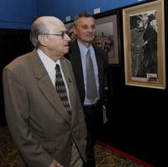 | John
VICE PRESIDENT AWF JOHN WARHOLA IN SLOVAKIA ( AWMMA MEDZILABORCE)

