Andy Warhol v kontexte finančnej recesie a jeho „totém“ v jej tieni na umeleckom trhu

V druhom májovom týždni roku 2009 sa uskutočnili aukcie súčasného umenia, organizované svetovou aukčnou sieňou Sothebys v New Yorku a Londýne. Po marcovom veľtrhu v Dubaji, aprílovom Tefaf v Maastrichte či nedávno skončenom veľtrhu v Hong Kongu, pre umelecký trh v čase globálnej hospodárskej krízy znamenali tieto dražby nielen návrat klientely do aukčných domov, ale aj naplnenie predpokladov expertov zaoberajúcich sa art biznisom o postupne prichádzajúcej novej pozitívnej vlne entuziazmu investovať do kvalitného umenia svetovo akceptovateľných mien v dejinách umenia a art biznisu.
Medzi stálice a opory súčasného umeleckého trhu patria takí umelci, ako J. Johns, J. Koons, F. Bacon, J.M. Basquiat, P. Picasso a Andy Warhol. Práve na posledných dražbách bol posledný z nich menovaný mimoriadne úspešný, keď ceny jeho diel sa dostávali aj niekoľko násobne vyššie nad sumu vyvolávajúcu, pričom je potrebné zdôrazniť, že v takzvanom „Condition report“, ktorý popisuje kondíciu diela, sa jednalo prevažne o obrazy s miernym alebo stredným limitom poškodenia. Zároveň chcem zdôrazniť, že niektoré z diel Andyho Warhola, predaných za niekoľko stotisíc dolárov, majú veľkosť poštovej obálky či formátu A4. Predpokladá sa, že ani v tomto roku Andy Warhol nebude chýbať v TOP 10 najlepšie zarábajúcich umelcov po smrti podľa rešpektovaného časopisu FORBES a po sérií jeho početných retrospektívnych výstav prevažne v Európe ( Štokholm, Moskva, Amsterdam, Londýn, Cleveland, Oslo, Praha... ) sa očakáva zvýšený záujem o jeho diela ako súčasť depozitu múzeí a galérií, či v kontexte súkromného vlastníctva.
Analyzujúc svetový trh s umením ( ale aj trh s umením na regionálnej úrovni jednotlivých štátov ), sa napĺňajú slová mnohých agentov či dealerov umenia ( Krieger, Procházka, Barker... ) o tom, že po skončení chaotického obdobia postmoderny už vlastniť dielo svetového umelca sa stane doslova luxusnou záležitosťou niekoľkých vyvolených, pretože ich dostupnosť bude čím ďalej tým viac komplikovanejšia, respektíve bude dostupná za vysoké cenové relácie.
Mgr. Martin Cubjak


LOT 184
ANDY WARHOL
1928 - 1987
KIMIKO POWERS
350,000—450,000 USD
Lot Sold. Hammer Price with Buyer's Premium: 506,500 USD bez poplatkov a dani
40 by 40 in. 101.6 by 101.6 cm.
DESCRIPTION :signed, titled and dated 72 on the overlap, synthetic polymer paint and silkscreen inks on canvas

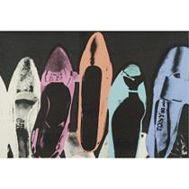
LOT 185
- ANDY WARHOL
1928 - 1987
UNTITLED (DIAMOND DUST SHOES)
80,000—120,000 USD
Lot Sold. Hammer Price with Buyer's Premium: 218,500 USD
40 by 60 in. 101.6 by 152.4 cm.

DESCRIPTION : acrylic and silkscreen ink on paper with diamond dust
Executed in 1980, this work is stamped by the Estate of Andy Warhol, and the Andy Warhol Foundation for the Visual Arts, Inc., and numbered 099EUT.069 on the reverse



LOT 186
ANDY WARHOL
1928 - 1987
FLOWERS
60,000—80,000 USD
Lot Sold. Hammer Price with Buyer's Premium: 122,500 USDbez dani a polatkov
5 by 5 in. 12.7 by 12.7 cm.

DESCRIPTION signed twice, dated 64 and dedicated To Todd Brassner on the overlapacrylic and silkscreen ink on canvas
Executed in 1965, this work is stamped by The Andy Warhol Art Authentication Board, Inc., and numbered A110.969 on the overlap.

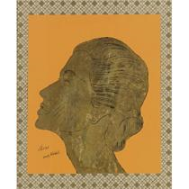

LOT 182
PROPERTY FORMERLY FROM THE COLLECTION OF DIONE GUFFEY KENZER
ANDY WARHOL
1928 - 1987
DIONE (PORTRAIT OF DIONE GUFFEY KENZER)
70,000—90,000 USD
Lot Sold. Hammer Price with Buyer's Premium: 158,500 USDbez dani a polatkov
overall: 19 5/8 by 15 1/2 in. 49.8 by 39.4 cm.

DESCRIPTION signed and titled, ink and gold leaf on paper, mounted on paper
__________________________________________________________________________________
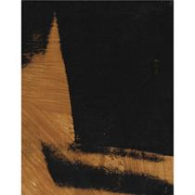

LOT 181
ANDY WARHOL
1928 - 1987
SHADOW
35,000—45,000 USD
Lot Sold. Hammer Price with Buyer's Premium: 50,000 USD
14 by 11 in. 35.6 by 27.9 cm.

DESCRIPTION signed on the overlap, synthetic polymer paint and silkscreen ink on canvas
Executed in 1978.

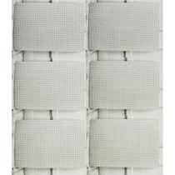

LOT 179
SOLD WITHOUT RESERVE
- ANDY WARHOL
1928 - 1987
UNTITLED (PEGBOARD)
20,000—30,000 USD
Lot Sold. Hammer Price with Buyer's Premium: 50,000 USDbez dani a poplatkov
30 3/4 by 27 1/8 in. 78 by 69 cm.

DESCRIPTION : stitched black and white photographs, in 6 parts, Executed in 1976-1986.
__________________________________________________________________________________

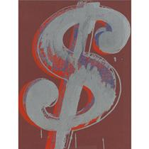

LOT 190
ANDY WARHOL
1928 - 1987
$
200,000—300,000 USD
Lot Sold. Hammer Price with Buyer's Premium: 314,500 USD
20 by 16 in. 50.8 by 40.6 cm.

DESCRIPTION : signed and dated 81 on the overlap, acrylic and silkscreen ink on canvas
Executed in 1981, this work is stamped by The Andy Warhol Art Authentication Board, Inc., and numbered A110.066 on the overlap.



LOT 194
ANDY WARHOL
1928 - 1987
CAMOUFLAGE
12,000—18,000 USD
Lot Sold. Hammer Price with Buyer's Premium: 40,000 USDbez daní a poplatkov
38 by 38 in. 96.5 by 96.5 cm.

DESCRIPTION stamped with the artist's name and date 1987 on the reverse; signed, titled and numbered T.P. 77/84 by Frederick Hughes on the reverse, silkscreen on paper
Executed in 1987, this work is a unique trial proof variation.
__________________________________________________________________________________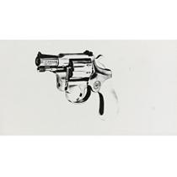
LOT 196
ANDY WARHOL
1928 - 1987
GUN
20,000—30,000 USD
Lot Sold. Hammer Price with Buyer's Premium: 32,500 USD
22 by 39 1/2 in. 55.9 by 101.3 cm.

DESCRIPTION : unique screenprint on paper
Executed in 1981, this work is stamped by the Andy Warhol Authentication Board, New York, and numbered A223.009 on the reverse.

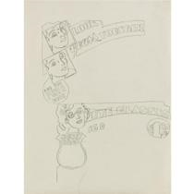

LOT 198
SOLD WITHOUT RESERVE
- ANDY WARHOL
1928 - 1987
LOOK YEARS YOUNGER
10,000—15,000 USD
Lot Sold. Hammer Price with Buyer's Premium: 42,500 USD
24 by 18 in. 61 by 42.7 cm.

DESCRIPTION : graphite on sketchbook paper
Executed circa 1960, this work is stamped by the Estate of Andy Warhol and the Andy Warhol Foundation for the Visual Arts, Inc. and is numbered 129.006 on the reverse.

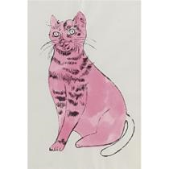

LOT 199
SOLD WITHOUT RESERVE
- ANDY WARHOL
1928 - 1987
SAM (FROM 25 CATS NAMED SAM AND ONE BLUE PUSSY)
15,000—20,000 USD
Lot Sold. Hammer Price with Buyer's Premium: 21,250 USD
19 1/2 by 13 1/2 in. 49.5 by 34.3 cm.

DESCRIPTION : hand-colored off-set lithograph, ink and watercolor
Executed in 1954, this work is stamped by the Estate of Andy Warhol and the Andy Warhol Foundation for the Visual Arts, Inc. and numbered PM 06.0096 on the reverse.

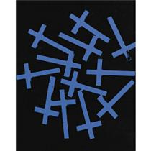

LOT 202
ANDY WARHOL
1928 - 1987
CROSSES
80,000—120,000 USD
Lot Sold. Hammer Price with Buyer's Premium: 128,500 USD
20 by 16 in. 50.8 by 40.6 cm.

DESCRIPTION : synthetic polymer paint and silkscreen inks on canvas
Executed in 1981-82, this work is stamped by the Estate of Andy Warhol and the Andy Warhol Foundation for the Visual Arts, Inc. on the reverse, stamped by the Estate of Andy Warhol and numbered PA14.014 on the overlap and numbered PA14.014 on the stretcher.
__________________________________________________________________________________

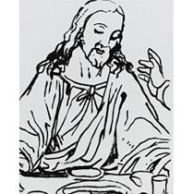

LOT 203
ANDY WARHOL
1928 - 1987
DETAIL OF THE LAST SUPPER
80,000—120,000 USD
Lot Sold. Hammer Price with Buyer's Premium: 218,500 USD
20 by 16 in. 50.8 by 40.6 cm.

DESCRIPTION : synthetic polymer paint and silkscreen ink on canvas. Executed in 1986.
This work is stamped by the Estate of Andy Warhol and the Andy Warhol Foundation for the Visual Arts, Inc., and numbered PA82.003 on the overlap; stamped by the Andy Warhol Foundation for the Visual Arts, Inc. on the reverse; numbered PA82.003 on the stretcher.

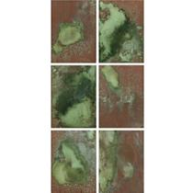

LOT 216
ANDY WARHOL
1928 - 1987
UNTITLED (OXIDATION PAINTINGS)
200,000—300,000 USD
Lot Sold. Hammer Price with Buyer's Premium: 338,500 USDbez polatkov a daní
each: 14 by 10 in. 35.6 by 25.4 cm.

DESCRIPTION : mixed media on canvas, in 6 parts
Executed in 1978, these works are each stamped by the Estate of Andy Warhol and the Andy Warhol Foundation for the Visual Arts, Inc., and numbered respectively, VFPA45.087, VFPA45.088, VFPA45.089, VFPA45.094, VFPA45.96, VFPA45.106 on the reverse.
__________________________________________________________________________________


LOT 221
SOLD WITHOUT RESERVE
- ANDY WARHOL
1928 - 1987
SOMEBODY WANTS TO BUY YOUR APARTMENT BUILDING!
400,000—600,000 USD
Lot Sold. Hammer Price with Buyer's Premium: 458,500 USD
72 by 80 in. 182.9 by 203.2 cm.

DESCRIPTION : synthetic polymer paint and silkscreen ink on canvas
Executed circa 1985-86.
This work is stamped twice by the Estate of Andy Warhol and the Andy Warhol Foundation for the Visual Arts, Inc., numbered twice PA10.238 on the overlap and numbered PA10.238 on the stretcher.

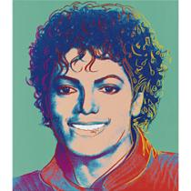

LOT 225
SOLD WITHOUT RESERVE
- ANDY WARHOL
1928 - 1987
MICHAEL JACKSON
250,000—350,000 USD
Lot Sold. Hammer Price with Buyer's Premium: 278,500 USD
30 by 26 in. 76.2 by 66 cm.

DESCRIPTION : synthetic polymer paint and silkscreen inks on canvas.
Executed in 1984, this work is stamped twice by the Estate of Andy Warhol and the Andy Warhol Foundation for the Visual Arts, Inc., and numbered twice P050.464 on the overlap.
__________________________________________________________________________________

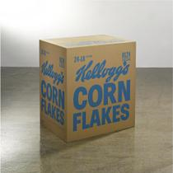

LOT 4
ANDY WARHOL
1928 - 1987
KELLOGG'S CORNFLAKES [LOS ANGELES TYPE]
200,000—300,000 USD
Lot Sold. Hammer Price with Buyer's Premium: 482,500 USD
27 x 24 x 19 in. 68.6 x 61 x 48.3 cm.

DESCRIPTION : silkscreen ink on plywood. Conceived in 1964, executed in 1970.

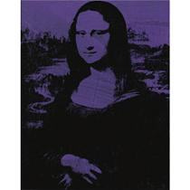

LOT 22
ANDY WARHOL
1928 - 1987
MONA LISA
1,500,000—2,000,000 USD
Lot Sold. Hammer Price with Buyer's Premium: 1,762,500 USD
25 x 20 in. 63.5 x 50.8 cm.

DESCRIPTION : acrylic and silkscreen ink on canvas
Executed in 1979, this work is stamped by the Estate of Andy Warhol and the Andy Warhol Foundation for the Visual Arts on the overlap and the reverse; also initialed by Vincent Fremont and numbered by the foundation PA63.005 on the overlap.
__________________________________________________________________________________
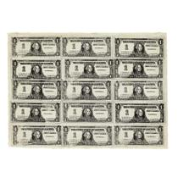

LOT 32
ANDY WARHOL
1928 - 1987
FIFTEEN ONE DOLLAR BILLS
750,000—1,000,000 USD
Lot Sold. Hammer Price with Buyer's Premium: 902,500 USD
21 1/4 x 29 in. 53.9 x 73.7 cm.

DESCRIPTION : signed and dated 1962 on the reverse, ink and pencil on Japanese rice paper

